**Power BI Week 1 Group Exercise 1**

https://github.com/fenago/cts245X/tree/main/CTS2451IntroToPowerBI/Exercises

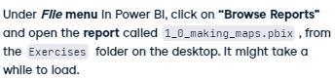

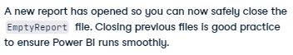

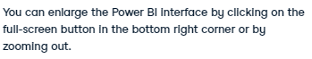

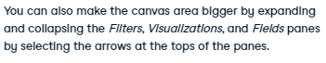



PART 2:

